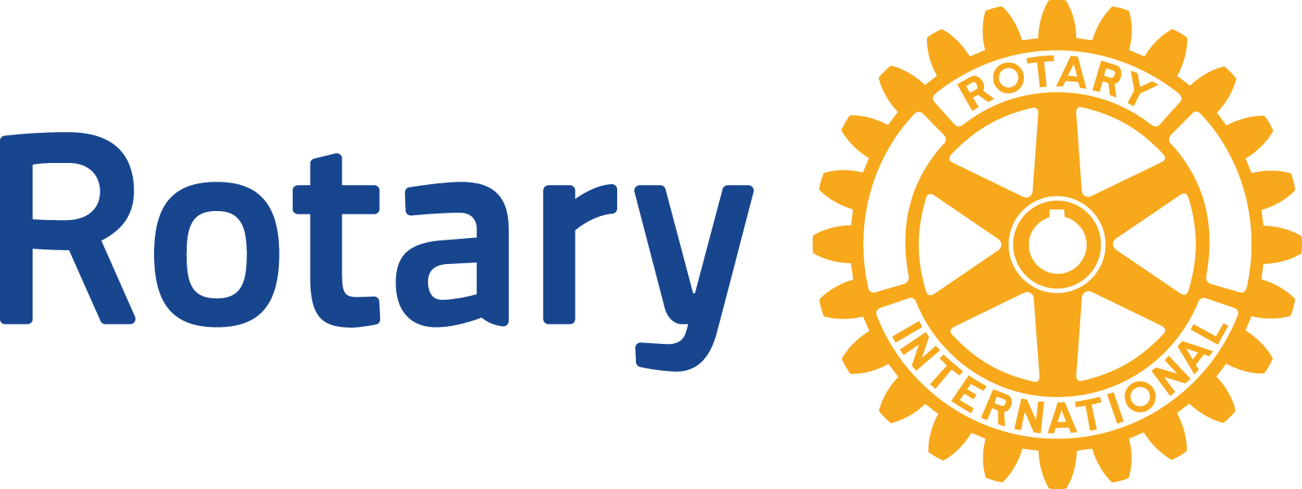

CLUB COMMUNICATION PLAN

Developing a Communication Plan

- Set measurable goals
- Focus on one campaign (or just a couple)
and do it well
- Assign the right team
- Establish a realistic budget
- Open your doors

What to Consider When Promoting Events

- Goal of Project
- Target Audience
- Key Messages to Target Audience (before, during and after the event)
- Role of Rotarians & Community in Project
- Type of Outreach Used
- Marketing Approach

Additional Questions to Consider

- What challenges might you discover in promoting this event?
- How might challenges be overcome?
- What type of traditional media will be used?
- How will social media be used?
- Will the event attract prospective members?
- What benefits will promoting this event bring?

