STRENGTHENING Rotary – A VOICE REFERENCE GUIDE

ENGLISH (EN)
OUR ESSENCE
JOIN LEADERS | EXCHANGE IDEAS | TAKE ACTION
Connect with leaders from all continents, cultures and occupations | Discover and celebrate diverse perspectives | Create positive change in our communities
- Rotary clubs  - Rotaract  - Interact | - International Convention  - Institutes  - Youth Exchanges | - Club service projects  - PolioPlus  - Rotarian Action Groups  - Rotary Community Corps

Our Values
OUR VALUES | HOW WE LIVE OUR VALUES
Fellowship and Global Understanding | We build relationships
Ethics and Integrity | We honor our commitments
Diversity | We connect diverse perspectives
Vocational Expertise, Service, and Leadership | We apply our leadership and expertise to solve problems

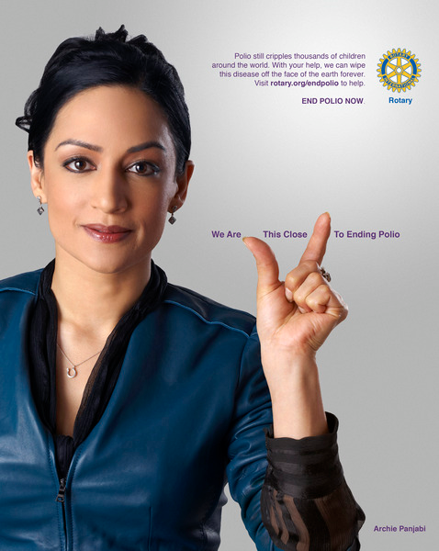
Our VOICE ATTRIBUTES
Persevering:
express our commitment when we speak with
clarity and conviction
Inspiring:
convey hope, enthusiasm and passion
Compassionate:
champion real people, stories and
conversations that are relatable and universal
Smart:
insightful and discerning

TIPS:
- Write in the ACTIVE voice.
- Use PERSONAL pronouns.
- Eliminate UNNECESSARY words.
- Avoid (or explain) Rotary terms.
- Shift focus from WHAT to WHY.
- Close with a call to ACTION.
- When addressing IMPACT, start locally and then scale globally.
- Focus on CONNECTIONS and COMMUNITY rather than individuals.
- PERSEVERING: express our commitment when we speak with
clarity and conviction
- INSPIRING: convey hope, enthusiasm and passion
- COMPASSIONATE: champion real people, stories and conversations that are relatable and universal
- SMART: insightful and discerning

QUESTIONS: General: Design-specific (logos, fonts, colors, etc.):
remarks@rotary.org graphics@rotary.org

