**Equipment:**

**Main PC** (Carol) – Host computer, from home or at the Legion, runs zoom controls, spotlighting, muting. May host zoom speaker PowerPoints. Speaker may also run from their own computer.

**Legion Podium PC** – logged into zoom; camera features President/Speaker; Mute audio in Zoom. Guest speaker may use for their presentations.

**Rotary Laptop at Legion** – may co-host, audio settings within Zoom are **USB** for both Microphone and Speakers. Connects to Mixer, TV, Webcam.

**Webcam on a selfie stick** – for in-person participation, selfie stick is also a tripod.

Plug USB into computer. Spot on Rotarians in the room during the meeting. Two 15’ USB cords extend the reach of the camera to carry around the room for Gratitude Dollars.

(Could use a second camera or phone, set up to show the President/Speaker to allow them to focus on the room vs. the computer camera.)

**Wireless microphones** – 2 (1 for podium, 1 for in-person participation)

Two XLR cords connect mic transmitter to the mixer

**Audio mixer** (Harbinger brand), Plug into power strip and computer.

Connects soundbar, mics, and Zoom call together to reduce feedback and to control volumes.

**TV:** Used as a monitor to view people on Zoom.

HDMI cable from TV to computer; TV plug-in cord to power strip

**Soundbar** – enables room to hear those on zoom. Mics feed through the sound bar. Zoom audio must be “On” for Legion Computer.

Plug into mixer and power strip. There are left and right speakers in the soundbar, so a split was needed for two plugs into the mixer. If no sound comes out, confirm Channel 2 is on for the soundbar.

**Reference:**

Rotary Computer PW: __________

Zoom account login (only for main PC)

User: [_________________________](mailto:Chanhassen.rotary@gmail.com)

PW: _________________________

Zoom meeting info (for Podium PC, cell phone, and all remote participants)

Meeting ID: **_________________** Passcode: _________________

Legion Wifi PW: __________ (may use personal iPhone hot spot if unreliable)

**Charging:**

Wireless microphones use AA batteries.

Computer charger may plug in for each meeting, or beforehand.

**Summary Set-Up:**

**Connections for Legion PC**:

* Webcam/Selfie Stick - USB
* Mixer – wide USB
* TV – HDMI (be sure it’s in HDMI on the TV if it gets unplugged)
* Computer charger if needed

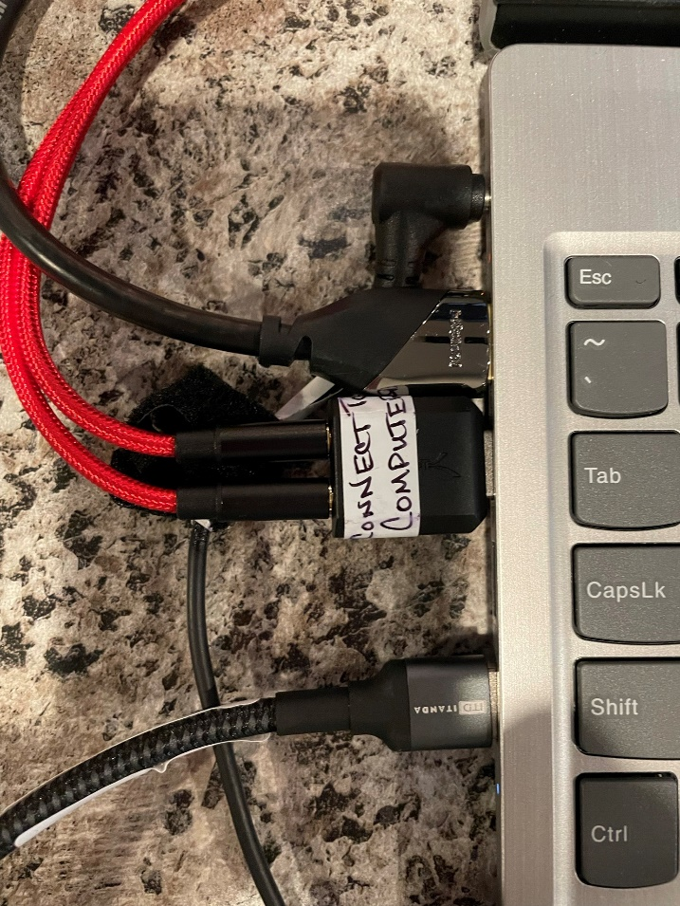

**Connections for Powerstrip**:

* TV
* Soundbar
* Mic Transmitter (plugs into back of transmitter)
* Mixer
* Computer charger if needed

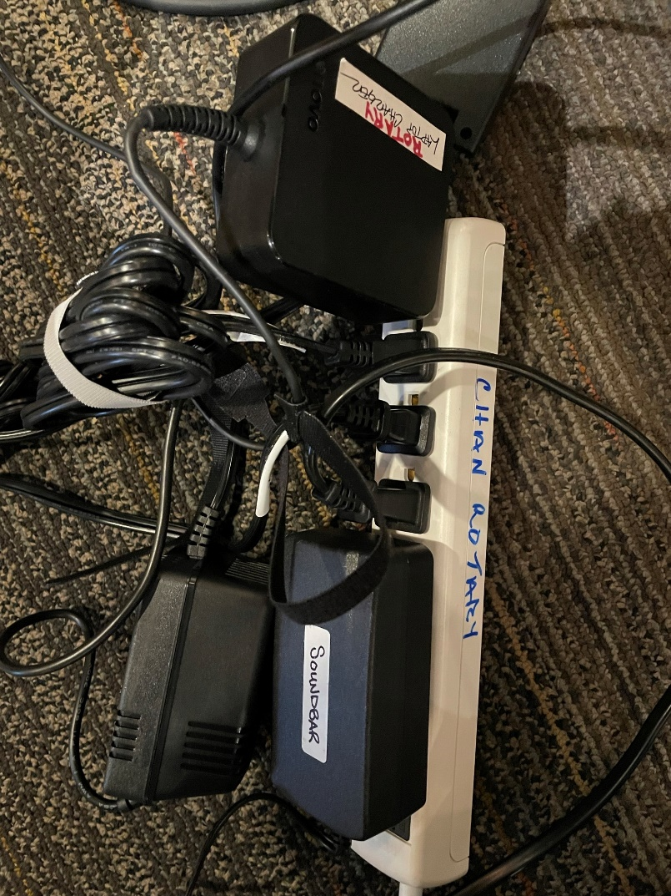

**Connections for Audio mixer:**

Soundbar

2-XLR Cables for Mics (1 & 2)

Typically use Auxiliary Out; but for this mixer, work-around: use Headphones(above Phones dial)

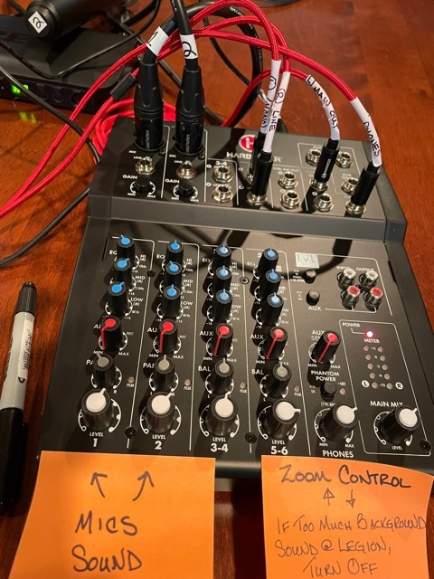

Mics

Soundbar

To Computer

Mics:

Press “Group” button inside the mics to find best frequencies. Set each Mic within the hand grip accordingly. (e.g., H1 and H7)

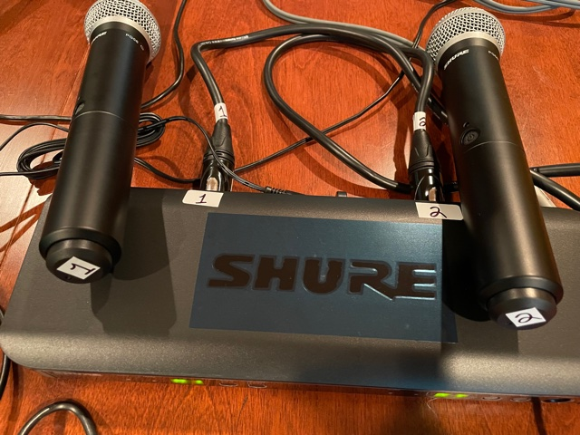

**Dials for Audio Mixer:**

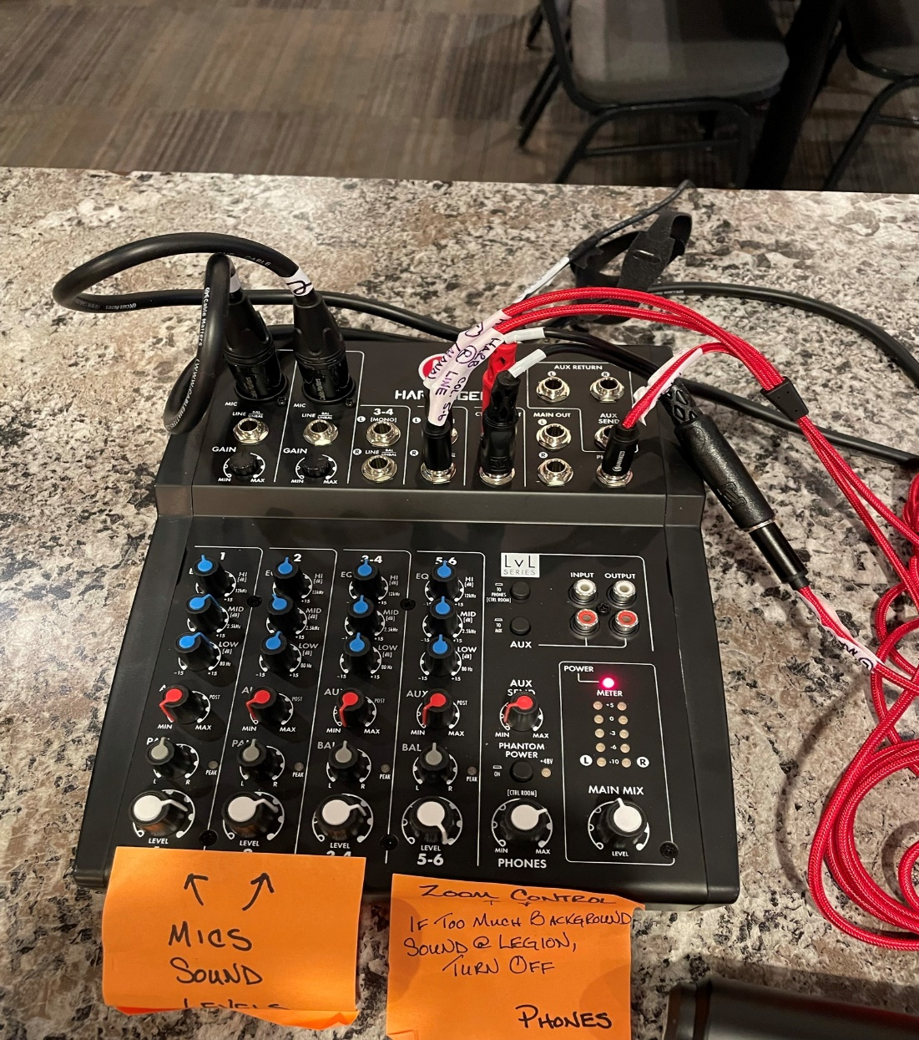

Mic 1 and Mic 2 Volume

MainMix Master Dial

Adjusts Gain

5-6 Controls Zoom Volume

**Description of Dials on the Mixer:**

**Mics:** Volume controls at bottom of Columns 1 and 2. XLR cables 1 and 2 take signal from transmitter to the mixer. Adapter changes the signal to USB.

To increase the **“gain”** (volume of the signal from the mics into the mixer), adjust the top dial in columns 1 and 2. Should be at 3,4,5 power. Mic In is for USB volume into Zoom. (At home, listeners can then adjust additional volume controls on their computer if desired.)

Next three dials: treble, middle, bass. Bottom dial is Volume Out/Aux Out. This adjusts each mic’s volume out.

Adjust volume on the soundbar using **Main Mix Master Dial**, far right. It’s a balance between the Volume Out dial at the bottom of columns 1 & 2, and the Master dial to get the mics balanced in Zoom and on the soundbar.

**Mic Volume for Zoomers:** controlled by Col. 5 & 6. Should be at 6-9. Higher comes into the mixer louder.

Goal: balance between 1 & 2 and 5 & 6 so only need the Master for control.

Turn 5 & 6 to zero if Zoomers want to talk amongst themselves.

**Carol Lee’s Instructions to Presenters** **on Zoom:** (Carol runs Zoom from her computer)

*You are most likely is very familiar with these tips. Just in case... I always like to pass along a few hints.*

*I will be the ZOOM host assisting you with audiovisual and want to be as prepared as possible for your material.*

*I don't know if you have a video to share, but in case you do, hints for sharing video are included here.*

* *PowerPoints and slide shows are generally not a problem, but sometimes we have seen some issues with videos - especially with the sound. If you want to share a web-based YouTube video or a website, please e-mail the link to me the evening before our meeting.   That way we can put the link in our chat messages and people could view on their own computer in case there are streaming issues when sharing. your screen.   Some people in our club have marginal WIFI.*

*Or, if presenter is using own computer: I'm assuming that you will be using your own computer to share it with ZOOM, so you can change slides at your own pace.*

*You probably already know these next few tips, but just in case:*

* *Ensure you close unneeded programs or websites on your computer, as extra open screens slow down your transmission ability.*
* *We will have you share your computer screen and run your PPT or PDF as a full screen slideshow, F5 (for most Windows computers is the shortcut key for you to start full screen from within the PowerPoint. PDFs use CONTROL L.*
* *You should make your slide show full screen before you share.  That way, when you click ZOOM's green share button, you will see a display of all the windows open on your computer and can just navigate directly to the full screen view.  Then click the "share” button at the bottom right of the selection screen.*
* *For PowerPoints, - If you want to use the presenter view to see the upcoming slide on your computer, check the box “use presenter view" in PowerPoints’ slideshow tab.  The audience will only see the current slide.*
* *If you have video, there is a checkbox in the share selection screen to "optimize for video."*
* *If you have two screens that you use, when sharing – in "display options" make sure that both screens show the same thing.*

If we chose to record the meeting: (we are not doing)

Host PC records in the cloud at the start of the session. Have the session running for tests well before the actual meeting. Simply edit in the main zoom account to clip anything you don't want. Clip to the start of the actual meeting.