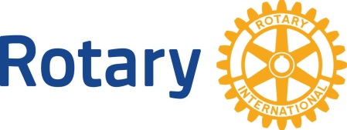
Rotary International
Date No. 4 Basics of Rotary

Dear (First Name):

Did you know that in 1905 a young lawyer, Paul Harris, founded the first Rotary club in Chicago, IL? 1invited a few business and professional men together so that they might recapture the friendliness and camaraderie of the small town life that many of them had known.

The club was called “The Rotary Club” because members met in rotation at their various places of work. Membership grew rapidly and the second Rotary Club was created in San Francisco, California. The first International Rotary club was organized in Winnipeg, Manitoba, Canada in 1910.

Rotary clubs now exist in over 200 countries and geographical areas. Although each club may have its own unique aspects of personality, culture, language, customs and traditions, all 34,000 clubs operate in an almost identical manner. The Standard Rotary Club Constitution outlines basic requirements for membership, attendance, weekly meetings, policies and procedures. When a club is admitted to membership in Rotary International, it is required to adopt the Standard Rotary Club Constitution. This Document gives the consistency of purpose and operations of Rotary clubs around the world.

Rotary International World Headquarters in Evanston, Illinois. If you hear the term “The Secretariat” it refers to the operations of the General Secretary and the more than 700 member staff. The Secretariat also include seven Rotary International offices around the world. The Secretariat’s purpose is to serve clubs, districts and the administrative officers of Rotary International

Rotary clubs are organized into Districts for administrative purpose—usually around 75 clubs and 2,700 Rotarians per district. Our club is part of District _____ with a total of ___ clubs and _____ Rotarians. Worldwide, our over 540 districts are grouped into 34 zones, with one Rotarian selected to represent two zones every two years. These 17 Rotarians serve on the Rotary International Board of Directors.

Rotary unites people around the world. When you shake the hand of one Rotarian you are shaking the hands of more than 1.2 million other Rotarians, all working to enrich youth, ensure health, build communities and promote peace.

Yours in Rotary Service,

