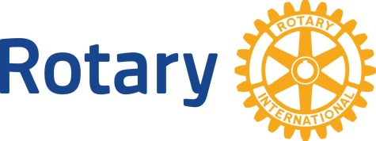
Rotary International

Date No. 9 Youth Service

Dear (First Name)

Youth Service is the avenue of service that recognizes the positive change that interacting with youth and young adults brings to our organization and to them. Leadership is an essential aspect of Rotary, and we offer programs to help emerging leaders strengthen their leadership skills, serve their communities, participate in exchange programs that enrich and foster world peace and cultural understanding, build friendships, and more.

Interact is a club for youth, ages 12-18, who want to connect with others in their community or
school. Interact club members have fun while carrying out service projects and learning about the
world. Interact clubs organize at least two service projects a year, one that benefits their
community and one that encourages international understanding. While Interact club members
receive guidance from a Rotary club, they govern and support themselves.

Rotaract clubs bring together young adults between the age of 18 to 40 in universities and
communities around the world to organize service activities, develop leadership and professional
skills, and have fun. Members of Rotaract clubs may also join a regular Rotary club and retain
dual membership in Rotaract and Rotary International.

Other opportunities to serve youth include reading to elementary school children and “partnering”
with XXX Elementary School, or the Dictionary Project, where our club members personally
deliver dictionaries to every 3rd grader in our community. We also sponsor leadership and ethics
training programs for high school student through RYLA (Rotary Youth Leadership Awards).

Hosting one of our exchange students is a wonderful way to bring the internationality of Rotary
into your own home, allowing your own children the chance to learn about another culture
without leaving their home or school. The relationships formed through Rotary Youth Exchange
often last a lifetime, with our members maintaining contact with their exchange sons or daughters
long after the exchange is completed. We also send our own youth abroad through this well
established program supported by Rotarians around the world.

Our five Avenues of Service provide many opportunities to get involved. We encourage you to find the projects or program that you would like to get directly involved in with our Club. We ask that you contact one of our Committee Chairs to join a committee this week. Please see your mentor or me if you would like to discuss which committee would be the best fit for you. Also, consider how your family members or friends may want to know ore about the wonderful youth programs offered by Rotary.

Yours in Rotary Service,

